FEC-18

ANALYSIS OF FINANCIAL STATEMENTS

**SATYAM SCAM ANALYSIS**

**ADITYA SINGH** 2K19/EP/005

Submitted to: **SAKSHI KUKREJA**

horizontal line

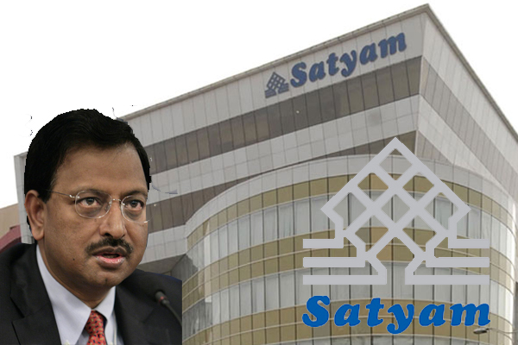

# Satyam, a word in Sanskrit — an ancient Indian language — means truth. Ironically, a company by the same name was involved in one of the largest scandals in the history of the Indian corporate world. On January 7, 2009, B. Ramlinga Raju, chairman of Satyam Computer Services Ltd., wrote a letter to the company board in which he took responsibility for fraud of about 50 billion Indian rupees (INR).

# INTRODUCTION

The fraud took the corporate world by surprise, not only due to its size but also because Satyam had been touted as a pioneer of corporate governance practices. Satyam won the Golden Peacock Global Award for Excellence in Corporate Governance given by the World Council for Corporate Governance in 2008, just three months before the scandal. Satyam also won the Golden Peacock National Award for Excellence in Corporate Governance in 2002, and was rated as having the best corporate governance practices by the Investor Relations Global Rankings (IRGR) for 2006 and 2007. In his letter, Raju acknowledged that the fraud had been going on for several years. As analysts tried to understand how a company with strong corporate governance practices could keep such a huge fraud under wraps, about 115 independent directors on the boards of listed Indian companies resigned in the one-month period following the Satyam scandal. Following the scandal, the big question facing the corporate world and the regulators was how to ensure good corporate governance, moving beyond the ceremonial adoption of best practices by firms.

# HISTORY OF SATYAM

Satyam Computers Limited (Satyam) was India’s fourth-largest software development and information technology (IT) consulting company based on 2008 figures. A private limited company incorporated by two brothers — B. Rama Raju and B. Ramalinga Raju — in 1987, Satyam’s success became synonymous with the success of the Indian IT industry for the next 20 years. Satyam was converted from a private limited company to a public company in August 1991, issuing shares to the public in 1992. The money raised in the stock market was used to build a software technology park and a 100 percent export-oriented unit. In the following year, Satyam made its first global foray by entering into a joint venture with the U.S. company Dun and Bradstreet. In 1996, Satyam set up its first foreign office in the United States, followed by another one in Japan. It developed new business partnerships in several other countries including Australia, Canada and some European countries. Meanwhile, Satyam continued its growth initiatives in the domestic market, opening new offices and facilities in different parts of India, promoting four subsidiaries — Satyam Spark Solutions, Satyam Renaissance Consulting Ltd., Satyam Enterprise Solutions Pvt. Ltd. and Satyam Infoway Pvt. Ltd. — and opening IT schools — the Indian Institutes of Information Technology (IIIT). The IIITs were a result of public-private partnership, with several of these schools being promoted by global corporations such as IBM, Microsoft and Oracle in different parts of India. In 1997, Satyam became the first Indian company to receive Information Technology Association of America (ITAA) certification for Y2K solutions.

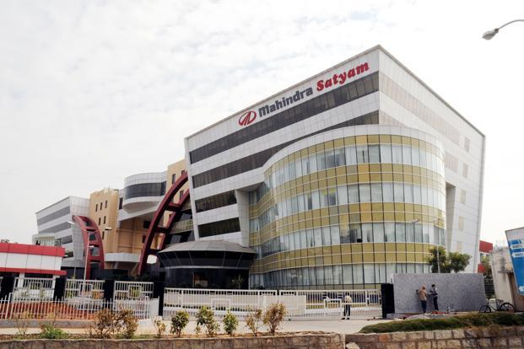

Along with its phenomenal growth, Satyam and its employees also won several national and international awards and recognitions. In 2000, Satyam was named a Web Business 50/50 award winner for its corporate intranet. In the same year, Satyam won the national Human Resource Development (HRD) Award for its outstanding HRD efforts. Dataquest, a leading IT magazine, named Raju as IT Man of the Year for 2000. Hong Kong-based Far Eastern Economic Review ranked Satyam as one of the 10 most well-regarded companies in India, based on a survey conducted in 2000. Satyam also won the Frost & Sullivan market engineering award for competitive strategy in 2001, and the application service provider category IBM Lotus award for innovation in 2003. These awards and honours were clear reflections of Satyam’s prestige and reputation amongst its clients, employees and society in general.

**THE UNFOLDING OF CRISIS**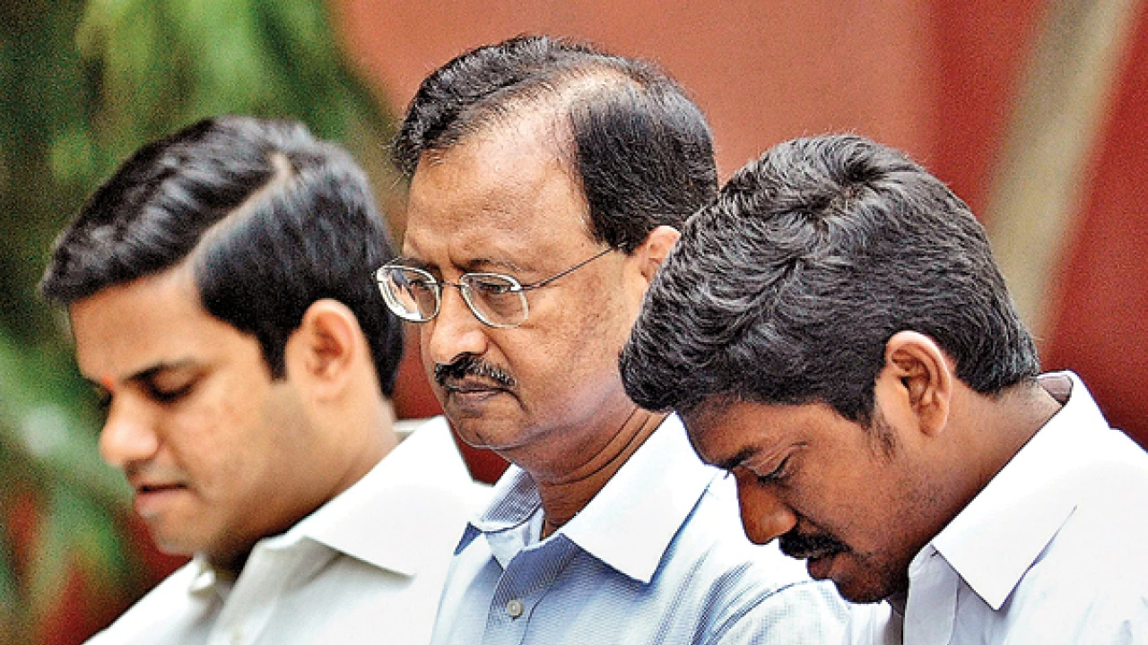

On December 16, 2008, Satyam’s board approved a 51 per cent stake acquisition of Maytas Infra, a listed company in the Bombay Stock Exchange for US$1.3 billion, and a 100 per cent stake in the unlisted firm Maytas Properties for US$300 million. The successful completion of the acquisition required borrowing US$300 million to add to the US$1.2 billion of cash that Satyam claimed to possess. Satyam justified the diversification into the real estate and property business on the grounds that real estate was a sunrise industry in India, and that diversification was essential given the sluggish growth of IT business in key markets such as the United States and Europe.

The investors reacted very negatively to this news, resulting in a 55 per cent decline in Satyam’s ADRs. Following stiff resistance from investors in general and institutional investors in particular, Satyam called off the acquisition on December 17, 2008; however, this did not pacify the negative sentiments and share prices, which fell by 30 per cent on the Indian bourses. Given the significant related party transactions involved, investors and media also started raising doubts over the corporate governance practices at Satyam; to restore investor confidence, Satyam scheduled a board meeting to consider a share buyback on December 29, 2008.

On December 23, the World Bank suspended Satyam for eight years from doing any business with itself, on the grounds that Satyam was offering bribes to World Bank staff for obtaining lucrative contracts. While Satyam vehemently denied the allegations, its share prices continued to fall. On December 28, Satyam postponed the board meeting scheduled for December 29; on the same day, Infrastructure Leasing and Financial Services (IL&FS) Trust sold 4.41 million Satyam shares at INR139.83 in the open market. Raju and his family had pledged these shares in lieu of the loans obtained from IL&FS Trust; as a result, Raju and his family’s stake in Satyam diluted to 5.13 per cent by late December, from a high of 8.65 per cent in September 2008.11 Satyam’s market capitalization eroded by 40 per cent in just two weeks in the latter half of December 2008.

**CONFESSION OF THE FRAUD**

In one of the biggest frauds in India's corporate history, B. Ramalinga Raju, founder and CEO of Satyam Computers, announced all of a sudden on January 7, 2009 that his company had been falsifying its accounts and doctoring the books of accounts of the company for years. The self confession “with deep regret and burden on conscience” plunged all stakeholders into deep trouble with a completely dark future. As per the confessions, company’s financial statements had overstated cash reserves of Rs. 5040 crores which did not exist, accrued interest of Rs. 376 crores, debtors Rs. 2160 crores, and understated liabilities of Rs. 1230 crores. The scale of India’s biggest corporate fraud was estimated at around Rs. 7000 crores. Raju was compelled to admit to the fraud following an aborted attempt to have Satyam invest $1.6 billion in Maytas Properties and Maytas Infrastructure -- two firms promoted and controlled by his family members. 

The Board of Directors of the company on December 16, 2008, cleared the deal of acquiring 100 percent stake in Maytas Properties and 51 percent stake in Maytas Infrastructure. Following the deal, institutional investors of the company who had 61.57 percent shareholding in the company (as on Sep. 30, 2008) questioned the propriety of using the software company’s cash pile to buy two infrastructure firms belonging to the promoters. The investors pummeled its stock on the New York Stock Exchange and Nasdaq. The board hurriedly reconvened the same day and the deal was aborted. The matter however didn't end there, as Raju might have hoped. In the next 48 hours, resignations streamed in from Satyam's independent directors. Resigning as Satyam's chairman and CEO, Raju said in the confession addressed to his board, the stock exchanges and the market regulator Securities and Exchange Board of India (SEBI) that Satyam's profits were inflated over several years to "unmanageable proportions" and that it was forced to carry more assets and resources than its real operations justified. He took sole responsibility for those acts.

**BALANCE SHEET ORIGINAL V/S ADJUSTED**

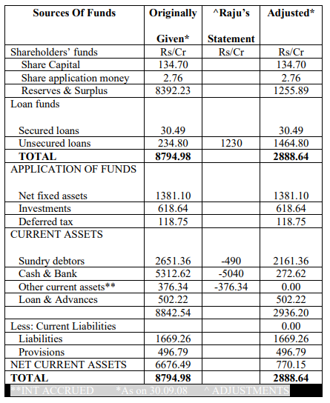

**BALANCE SHEET (5 YEARS MERGED)**

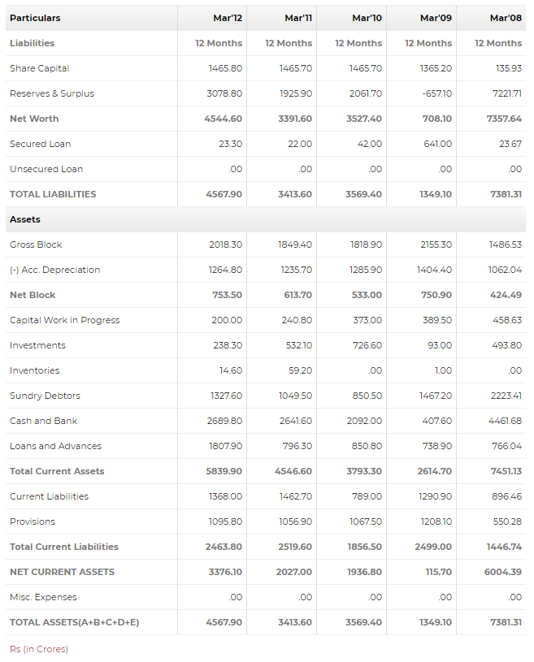

**FINANCIAL & SHARE MARKET DATA**

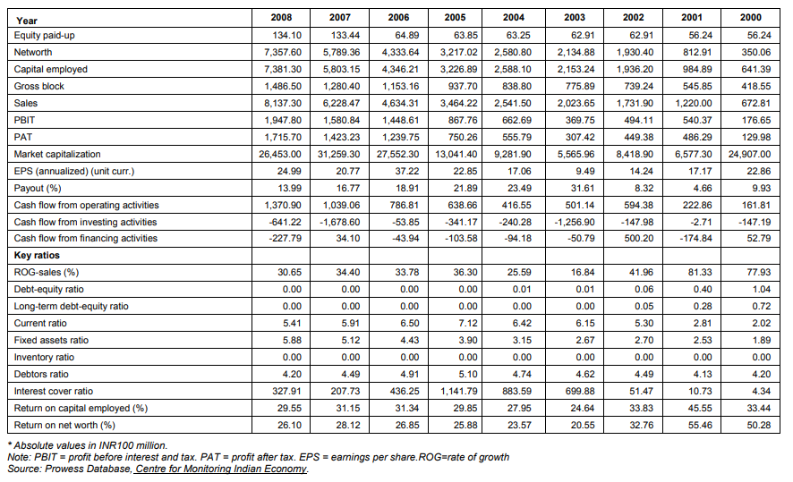

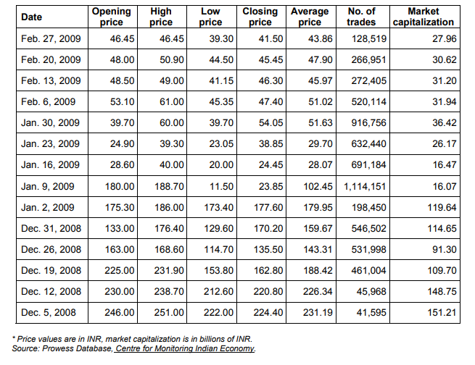

**RATIO ANALYSIS BEFORE DISCLOSURE**

1. **CURRENT RATIO**

Current Ratio = Current Assets / Current Liability

An indication of a company's ability to meet short-term debt obligations; the higher the ratio, the more liquid the company is. Current ratio is equal to current assets divided by current liabilities. If current liabilities exceed current assets, then the company may have problems meeting its short-term obligations.

|  |  |  |  |
| --- | --- | --- | --- |
| **Year** | **Current Assets (Rs. In Crores)** | **Current Liabilities (Rs. In Crores)** | **Current Ratio** |
| 2003-04 | 2,595.52 | 353.59 | 7.340479086 |
| 2004-05 | 3,283.53 | 451.64 | 7.270237357 |
| 2005-06 | 4,473.26 | 707.27 | 6.324685057 |
| 2006-07 | 6,003.75 | 1041.75 | 5.763138949 |
| 2007-08 | 7,451.13 | 1446.74 | 5.150289617 |

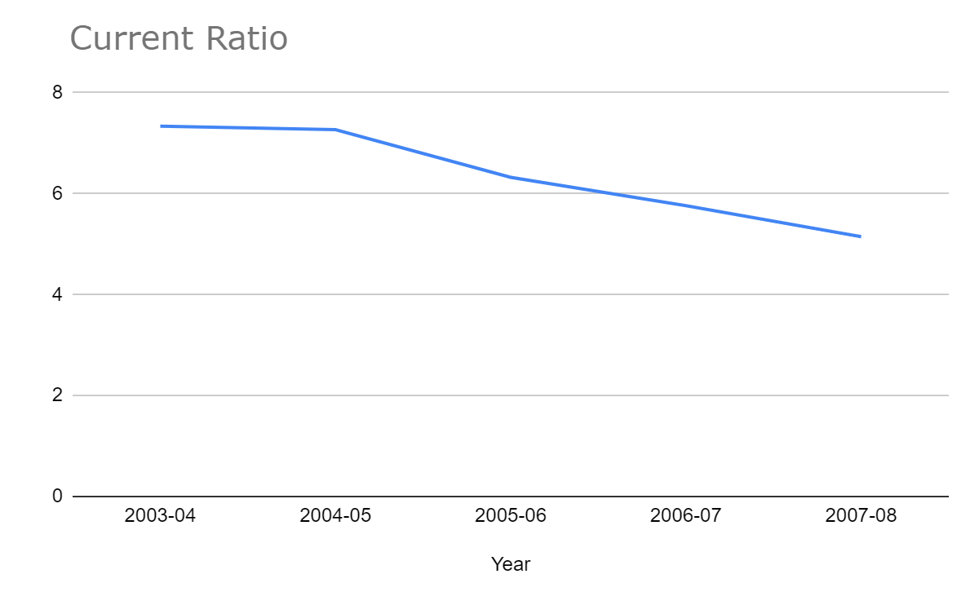

**Interpretation:**

Here, the current ratio fluctuates from year to year about the value of 6. If the current assets of a company are more than twice the current liabilities, then that company is generally considered to have good short-term financial strength. Thus, Satyam’s balance sheets indicated good financial strength up till the year 2008.

1. **QUICK RATIO**

Liquid ratio is also known as ‘quick’ or ‘Acid test ‘ratio. Liquid assets refer to assets which are quickly convertible into cash. Current Assets, other stock and prepaid expenses are considered as quick assets. The ideal liquid ratio accepted ‘norm’ for liquid ratio ‘1’.

Quick Ratio = Total Quick Assets/ Total Current Liabilities

Quick Assets = Total Current Assets (minus) Inventory

|  |  |  |  |
| --- | --- | --- | --- |
| **Year** | **Quick Assets (Rs. In Crores)** | **Current Liabilities (Rs. In Crores)** | **Quick Ratio** |
| 2003-04 | 939.02 | 194.53 | 4.827121781 |
| 2004-05 | 1324.09 | 262.87 | 5.037052535 |
| 2005-06 | 2266.99 | 435.71 | 5.202979046 |
| 2006-07 | 2243.02 | 621.3 | 3.61020441 |
| 2007-08 | 3366.51 | 896.46 | 3.755337661 |

**Interpretation:**

Satyam, being a software company has zero inventories. Hence the current ratio is equal to the quick ratio for Satyam.

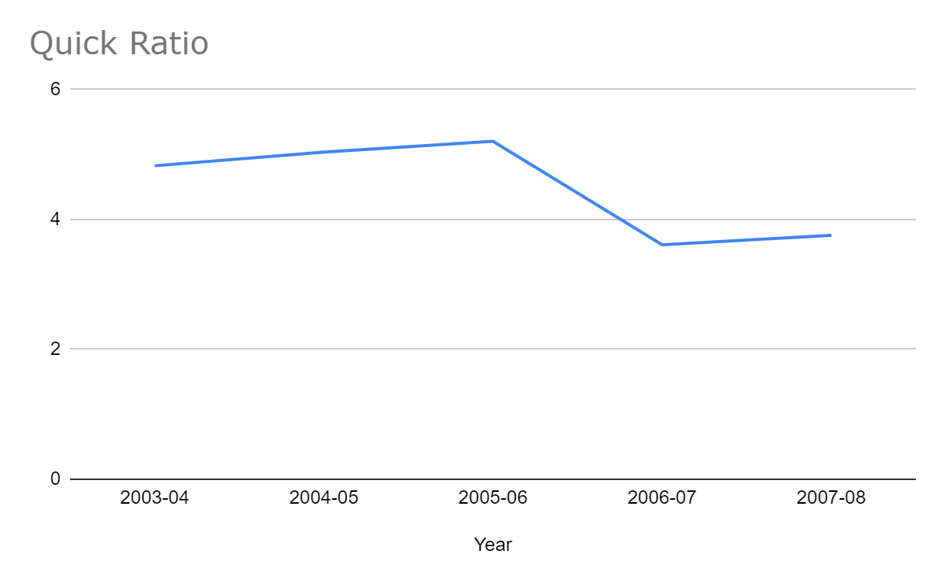

1. **TURNOVER RATIO**

Asset Management or Turnover Measure ratios are intended to describe how efficiently, or intensively, a firm uses its assets to generate sales.

Asset Turnover Ratio = Total Revenue / Total Assets

|  |  |  |  |
| --- | --- | --- | --- |
| **Year** | **Total Revenue (Rs. In Crores)** | **Total Assets Liabilities (Rs. In Crores)** | **Asset Turnover Ratio** |
| 2003-04 | 2620 | 2588.25 | 1.012266976 |
| 2004-05 | 3,545.19 | 3,227.34 | 1.098486679 |
| 2005-06 | 5,011.39 | 4,347.99 | 1.152576248 |
| 2006-07 | 6,409.29 | 5,803.15 | 1.104450169 |
| 2007-08 | 8,392.71 | 7,381.31 | 1.137021748 |

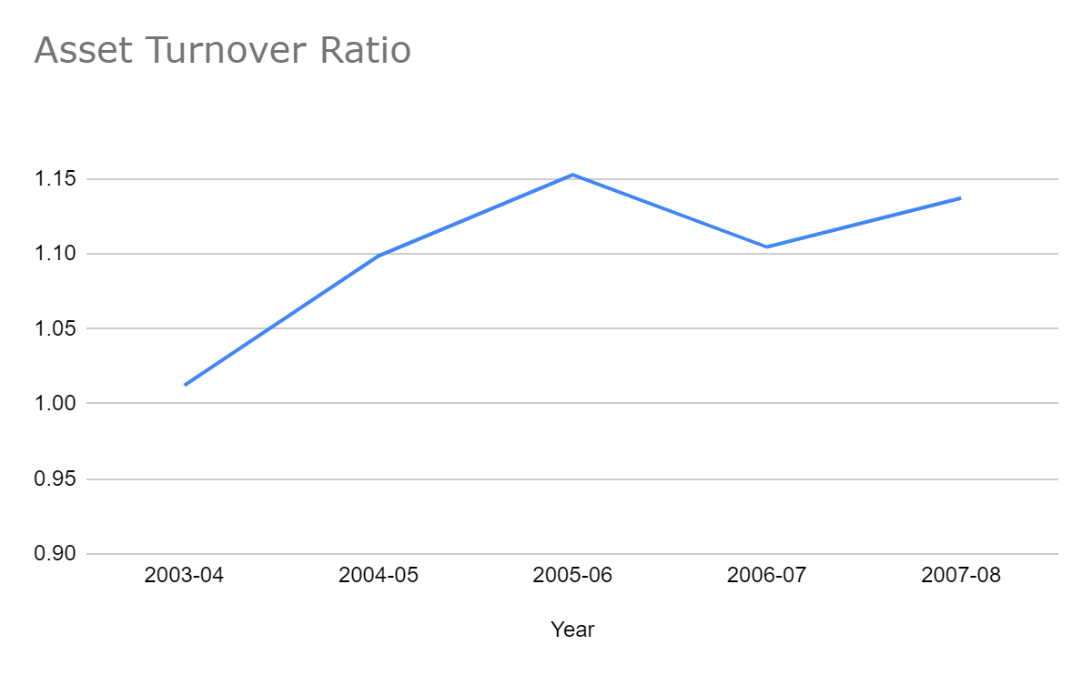**Interpretation:**

There has been a decline in the year 2006-07 but rising otherwise which indicates that the net fixed assets are used more effectively to increase the sales without additional investment in the period of study.

1. **NET PROFIT MARGIN**

This ratio helps in determining the efficiency with which affairs of the business are being managed. An increase in the ratio over the previous period indicates improvement in the operational efficiency of the business. The ratio is thus on effective measure to check the profitability of business. However, constant increase in the above ratio after year is a definite indication of improving conditions of the business.

Net Profit Margin = ( Net Profit / Net Sales ) * 100

|  |  |  |  |
| --- | --- | --- | --- |
| **Year** | **Net Profit (Rs. In Crores)** | **Net Sales (Rs. In Crores)** | **Net Profit Ratio** |
| 2003-04 | 555.79 | 2,541.55 | 21.86815132 |
| 2004-05 | 750.26 | 3,464.23 | 21.65733799 |
| 2005-06 | 1,239.75 | 4,634.31 | 26.75155525 |
| 2006-07 | 1,423.23 | 6,228.47 | 22.85039504 |
| 2007-08 | 1,715.74 | 8,137.28 | 21.08493256 |

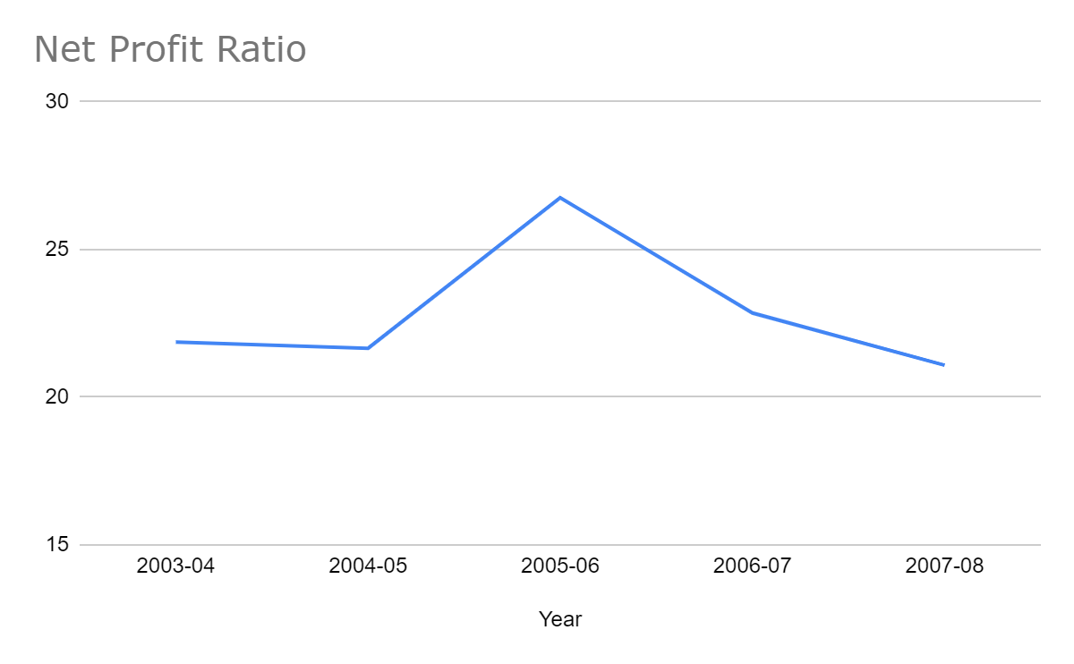**Interpretation:**

The profit margin was seen to be fluctuating around 23%. Since it was continuously positive, Satyam’s financial statements indicated a good profit margin.

1. **EARNINGS PER SHARE**

The overall profitability can also be judged by calculating earnings per share. The earnings per share measure helps in determining the market price of the equity shares of the company. A comparison of earning per share of the company with another will also help in deciding whether the equity share capital is being effectively used or not. It also helps in estimating the company’s capacity to pay dividend to its equity shareholders.

Earning Per Equity Share = ( Net Profit after Tax / Number of Equity Shares ) * 100

|  |  |  |  |
| --- | --- | --- | --- |
| **Year** | **Net Profit (Rs. In Crores)** | **Share in Issue (Rs. In Crores)** | **Earning Per Share** |
| 2003-04 | 555.79 | 3,162.52 | 17.57427621 |
| 2004-05 | 750.26 | 3,192.65 | 23.49960065 |
| 2005-06 | 1,239.75 | 3,244.50 | 38.21081831 |
| 2006-07 | 1,423.23 | 6,671.96 | 21.33151278 |
| 2007-08 | 1,715.74 | 6,704.79 | 25.58976493 |

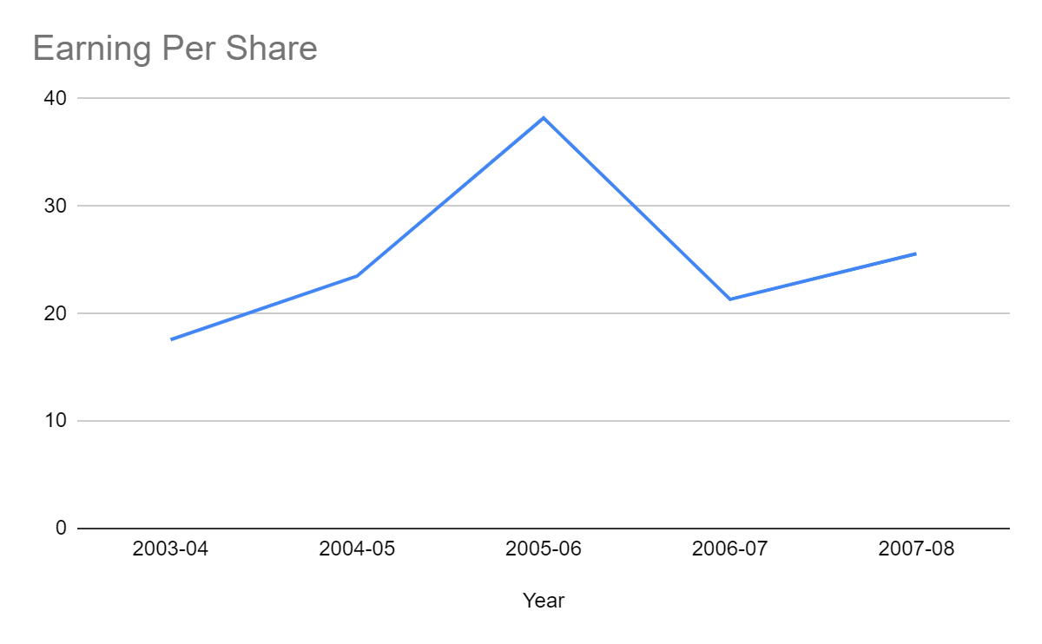

**Interpretation:**

Earnings Per share for the year 2005 is 150% higher than 2004 due to more Net Profit as the consequence of high sales value and low interest charges. In the year 2006 and 2007 earnings per share is comparatively less compared to 2005 due to economic conditions.

**AFTER DISCLOSURE OF SCANDAL** (in January 2009)

* **Comparison with earlier results and comparison with Infosys Technologies**

|  |  |  |  |
| --- | --- | --- | --- |
| **For Mahindra Satyam** | |  |  |
|  |  |  |  |
| **Year/Values** | **Net Profit Margin** | **EPS Values** | **Debt Equity Ratio** |
| 2009-2010 | -2.26% | 25.24 | 0.0091 |
| 2008-2009 | -9.28% | -121.49 | 0.4667 |
| 2007-2008 | 21% | -1.14 | 0.0299 |
|  |  |  |  |
|  |  |  |  |
| **For Infosys Technologies** | |  |  |
|  |  |  |  |
| **Year/Values** | **Net Profit Margin** | **EPS Values** | **Debt Equity Ratio** |
| 2009-2010 | 27.37% | 78.15 | 0 |
| 2008-2009 | 28.02% | 101.58 | 0 |
| 2007-2008 | 26.26% | 101.3 | 0 |

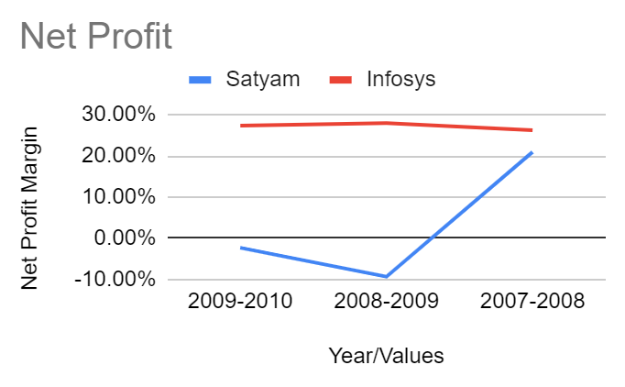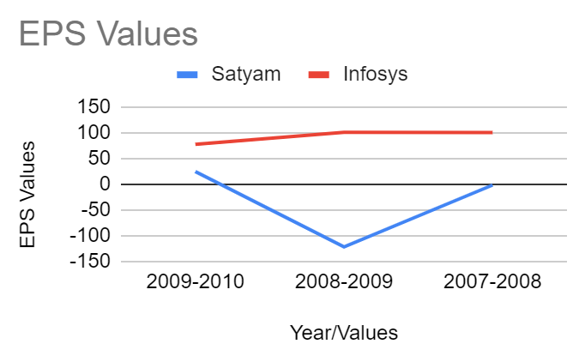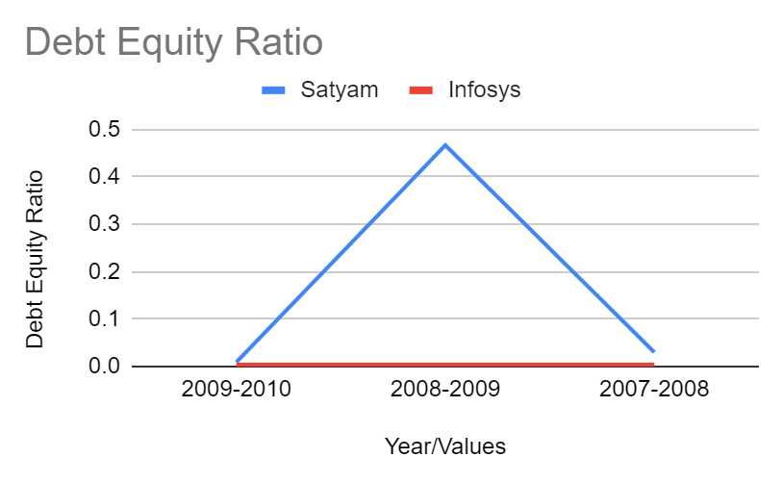

**CONCLUSION**

By watching the individual and comparative analysis of Satyam, both individually with its previous results and with Infosys Technologies, we find that the EPS, Debt-Equity Ratio and Profit Margin of Infosys is much higher than Satyam. Also the data and the graph shows that the values for Satyam drastically decreased in the year 2008-2009. This is a clear reflection of the effect of the scandal at Satyam which got revealed in January 2009. The leverage value (Debt-Equity ratio) for Satyam increased by 51 times in 2008-09. In comparison, Infosys has no leverage at all.

**THE END**